Instructions to connect to all the data warehouses we will use in this/these unit(s).

**A.**

**The first step is for you to download a SQL client.**

I suggest Azure Data Studio as a good client - also on AppsAnywhere. I will use Azure Data Studio during teaching.

Link to download and install: <https://learn.microsoft.com/en-us/azure-data-studio/download-azure-data-studio?tabs=win-install%2Cwin-user-install%2Credhat-install%2Cwindows-uninstall%2Credhat-uninstall#install-azure-data-studio>

Alternatively you can use DBeaver client

Link to download and install:

<https://dbeaver.io/download/>

Or

VSCode

Link to download and install: <https://code.visualstudio.com/download>

I have written a different guide on how to use VSCode. This can be accessed [here](https://github.com/Prayance/RecyclingDB/blob/master/StartFile.txt).

**B.**

**Verify that you have a DB account and you have the account details in front of you.**

Each will have received their own username and password account via email by now. If this is not the case please email me [elisavet.andrikopoulou@port.ac.uk](mailto:elisavet.andrikopoulou@port.ac.uk) ASAP!

**C.**

**Install and connect to the University of Portsmouth VPN!**

To install the UoP VPN on your computer follow the steps: <https://myport.port.ac.uk/guidance-and-support/it-help/vpn-guide>

**D.**

**Connect to the database:**

1. Make sure you are connected to the UoP VPN (see C)
2. Open Azure data studio (see A)
3. Click on the New connection
4. Complete the fields as shown in the picture below

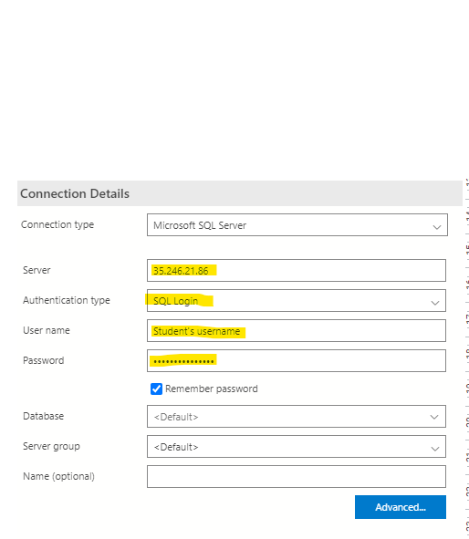

1. Make sure that your username and password that you are using, are the ones provided (see B).

**At this stage you are ready and you should be able to view the databases, namely HappyBakery and TiorGames**